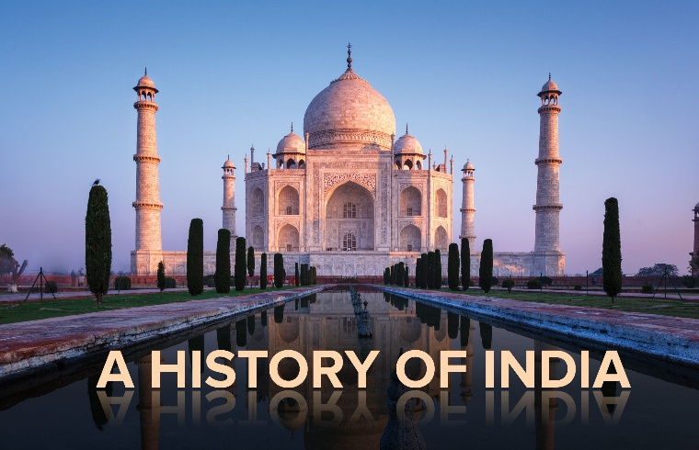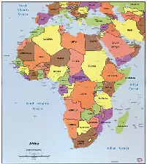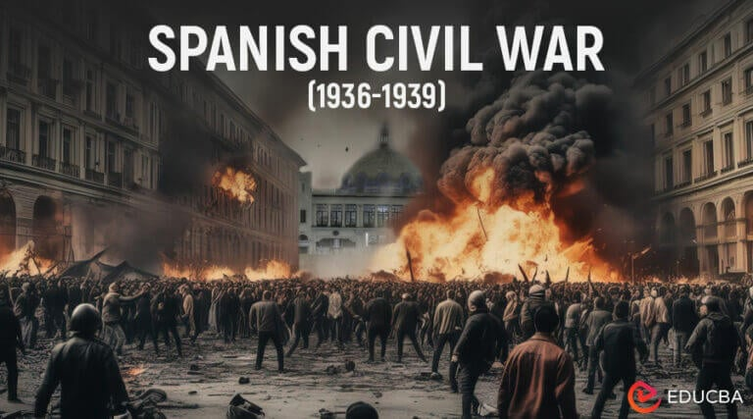

Some World History Again!
Stanford History Group 2026 Program
Monday evenings at 7.30p.m. Upper Sapey Village Hall, Upper Sapey WR6 6EU

5th October The Spanish Labyrinth I: From Civil War & Francoism 1936-1975

12th October The Spanish Labyrinth 2: Transition, Democracy & Monarchy 1975-2022
Senior Teaching Fellow Antonio Sanchez Univ. of Birmingham
19th October The Trump Administration: something different or More of the Same? 1 From Settler Colonisation and Slavery to keeping the world safe for Democracy

26th October 2 From the Cold War to the War on Terror
Lecturer John Munro Univ. of Birmingham
2nd November Stabilising the level of Economic Activity, 1930’s to the present
1 Keynes and Keynesianism –Pre WW2 to 1960’s
9th November 2 Monetarism and After - 1970’s to 2010’s
Professor Roger Backhouse Univ. of Birmingham
16th November The Rise and Fall of the East India Company
23rd November The British Raj and its Undoing
Professor Neil Fleming Univ. of Worcester

30th November The Decolonization of Africa: Success, Disappointment, and Hope
7th December The End of Empire in the Sahara: The Tragedy of the Commons?
Associate Professor Berny Sebe University of Birmingham
COSTS: The full course £70 or £10 for an individual lecture payable on the door or by bank transfer.
CONTACTS: https://stanfordhistorygroup.com
Simon Marriott 01886 853 412 simon@adamswoodfarm.co.uk David Kirrage 07899 817490 david.kirrage@icloud.com
Karon Jamous 07974 981275 karonjamous@aol.com Alan Stuttard 01886 853 465 ajstuttard@gmail.com
Rosemary Smart 01905 621 895 ra.smart@kirk12.plus.com Simon Neary 01584 781698 simon.neary1@googlemail.com

