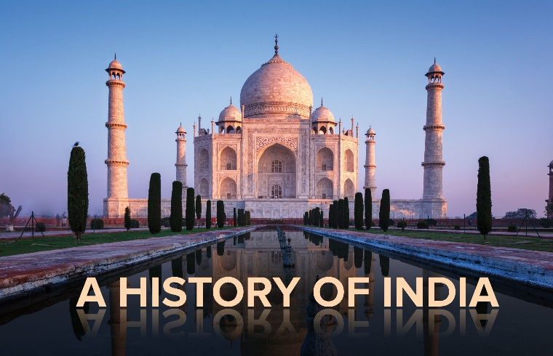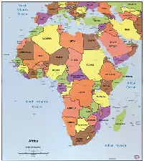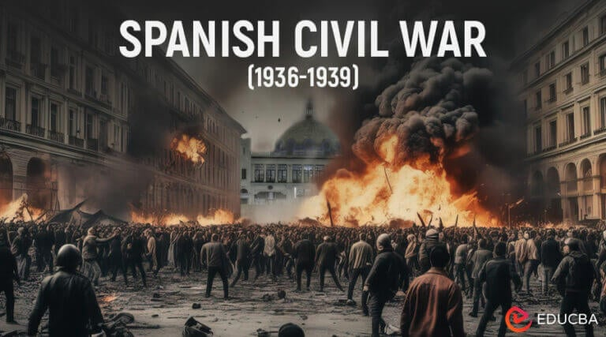

Some World History Again!
Stanford History Group 2026 Program
Monday evenings at 7.30p.m. Upper Sapey Village Hall, Upper Sapey WR6 6EU

https://stanfordhistorygroup.com

5th October The Spanish Labyrinth I: From Civil War & Francoism 1936-1975
This lecture will deal with the period 1936, which marks the outbreak of the Civil War to the year 1975 when the dictator Francisco Franco’s death put an end to his regime and sparked the process that led to the return of democratic governance. Initially, it will look at the the more immediate internal as well as external causes that account for the descent into civil confrontation. Next it will move to consider the consequences of the triumph of the rebel forces commanded by Franco. In the last part, it will chart the trajectory of Francoism in an attempt to account for its largely unchallenged longevity, its evolution and different phases.

12th October The Spanish Labyrinth 2: Transition, Democracy & Monarchy 1975-2022
The initial part of this presentation will explore the complexities and intricacies of the transition to democracy and the obstacles to its consolidation. Next the long tenure in office of the Socialist Party will be approached as a period of modernisation and full incorporation into European political institutions, extended during the Conservative governments from 1996 to 2004. The final part will deal with the resurgence of the memory of the Civil War in public debates since the late 1990s/early 2000s, which will be linked to the unravelling of the imperfect two-party system and the erosion of the political consensus that defined the transitional and early democratic period.
Senior Teaching Fellow Antonio Sanchez Univ. of Birmingham
19th October The Trump Administration: something different or More of the Same? 1 From Settler Colonisation and Slavery to keeping the world safe for Democracy
This lecture will consider the Andrew Jackson, William McKinley, and Woodrow Wilson administrations in context. With President Jackson, we will take up the relationship between white supremacy and the US economy. With McKinley, we will look at the international expansion of US power. And with Wilson, we will examine the interaction between US foreign policy and colonialism.
26th October 2 From the Cold War to the War on Terror
In this lecture, the Harry Truman, Ronald Reagan, and George W. Bush administrations will come into focus. With Truman, empire and cold war will provide crucial context. With Reagan, neoliberalism will become an important keyword. And with Bush, neoconservatism and extractivism will shape our analysis. All of this will set the stage for a larger discussion of where the Donald Trump administration might and might not depart from previous presidential scripts.
Lecturer John Munro Univ. of Birmingham

2nd November Stabilising the level of Economic Activity, 1930’s to the present
- Keynes and Keynesianism –Pre WW2 to 1960’s
Keynes and Keynesianism The first half will cover Maynard Keynes himself, a fascinating figure quite apart from his 1936 magnum opus, and a non-technical account of how his ideas evolved during the 1920s and 1930s in response to changing circumstances. The second half will sketch how Keynes's ideas were taken up in the 1940s, and were then developed into the paradigm that dominated policy making in the 1960s. This will touch on the role of the Second World War, developments in academic economics, and politics.
9th November 2 Monetarism and After - 1970’s to 2010’s
Monetarism and After The first half will focus on Milton Friedman and the rise of monetarist policies under Margaret Thatcher and Ronald Reagan, against the background of the problems that hit the world economy in the 1970s. The second half will explain how and why academic economics went in a different direction, the outcome being the consensus, neither traditional Keynesianism nor Friedman’s monetarism, that dominated policy making in the early 21st century.
Professor Roger Backhouse Univ. of Birmingham
16th November The Rise and Fall of the East India Company
'John Company' was the dominant force through which the British increased their trade, influence and later territorial control of India. Success brought increased criticism in Britain as well as India, and the system of 'double government' in which the Company and Crown in partnership ruled a subcontinent still nominally under the control of Mughal emperors. Even so, it was not until 'the Company' alienated its key Indian collaborators--the army--that mutiny and widespread rebellion shook British imperialism to its core.

23rd November The British Raj and its Undoing
British Indian policy in the wake of the mutiny-revolt prioritised security. It also widened the gulf between rulers and ruled. The latter, however, ran counter to British officials' growing reliance on the middle-class to administer the subcontinent's vast geography and complex demography. From their ranks, frustrated demands on the British to share power with Indians evolved into calls for 'home rule' and later 'independence'. Yet, throughout, even during the Second World War, British rule benefited from divisions in Indian society, even among supporters of self-government.

Professor Neil Fleming Univ. of Worcester

30th November The Decolonization of Africa: Success, Disappointment, and Hope
In which ways has the “end of empire” impacted the African continent? Between the dream of an emancipated future, freed from the colonial shackles, and the realities of war, famine and under-development, what did decolonisation mean for the 54 countries that make up this continent? Examining African history, politics and economy, this paper offers a contrasted portrait of a continent for which many see a bright future for the twenty-first century.
7th December The End of Empire in the Sahara: The Tragedy of the Commons?
Having been divided between four colonial powers during half a century, the Sahara experienced an unusual decolonisation. For the inhabitants of the largest desert in the world, independence often meant that political power remained in the hands of leaders out of touch with their realities, only interested in extracting underground riches. From water to oil, gas, uranium, iron and gold, they have attracted unwanted geopolitical interest, often leading to bloodshed, instability and violence. The wealth that lies beneath the Saharan sands appears to be both a blessing and a curse.
Associate Professor Berny Sebe University of Birmingham

